



**METRIC CONVERSION**

**CERTIFICATE**

This is to certify that the students

* **M. Arsalan Warsi** Student 1519372
* **M. Saqib Ahmed** Student 1523310
* **M. Humam** Student 1519374
* **M. Younus** Student 1521594
* **M. Wasiq Khan** Student 1518340

Of batch **PR2-202309E** have successfully completed the given task for the topic

**FACULTY: SIR FAIZ**

**SEMESTER CPISM APTECH LEARNING SHAHRAH-E-FAISAL**

# ACKNOWLEDGE

In today's fast-paced IT industry, professionals are expected to learn new skills quickly and apply them effectively. However, busy work schedules, remote locations, and inconvenient time slots often make it difficult to practice these skills in real-world scenarios. This challenge is especially significant for students who need to integrate and apply their knowledge continually. The rapidly changing technology landscape adds to this difficulty, as students must constantly update their skills to stay relevant.

Recognizing these challenges, Aptech is committed to revolutionizing the way students learn and implement IT concepts. We understand that traditional learning methods may not always be practical given the constraints of modern life. Therefore, we are introducing a live and synchronous e-Project learning environment. This innovative approach leverages technology to create a dynamic and interactive platform where students can work on real-time projects.

In this e-Project environment, students will have the opportunity to apply the concepts they learn in a practical setting. This hands-on experience is crucial for mastering IT skills and staying competitive in the industry. The live aspect of this platform ensures that students receive immediate feedback and support, enhancing their learning process.

By integrating this advanced learning model, Aptech aims to bridge the gap between theoretical knowledge and practical application. Our goal is to provide students with the tools and resources they need to succeed in their IT careers, despite the challenges posed by their busy schedules and the ever-evolving nature of technology.

# SO, WHAT IS THIS E-PROJECT?

E-Project is a step-by-step learning environment that makes learning feel like you're in a real classroom or lab. It lets you work on projects right from your computer, just like you would in person. It's a live, online tool that allows you to practice and apply what you learn easily and conveniently.

1. Practice step-by-step, like climbing a ladder.
2. Build a bigger and stronger application.
3. Use various tools in your own designed applications.
4. Combine smaller programs into one complete application.
5. Learn how to implement concepts gradually.
6. Improve your skills and add value.
7. Work on real-life projects.
8. Get real-life scenarios to create more complex and useful applications.
9. Receive mentoring through email support.

**METRIC CONVERSION**



This website focuses on customers needing efficient and accurate metric conversion tools. We offer a wide selection of popular conversion categories, including length, , volume, temperature, and more. Our tools provide detailed specifications and a variety of commonly used and affordable conversion options. Stay up-to-date on the latest trends and technology in metric conversion without compromising on ease of use or functionality.

# PROJECT ANALYSIS

|  |  |  |  |  |
| --- | --- | --- | --- | --- |
| **NAME** | **DATABASE** | **FRONT END** | **BACKEND CODING** | **DOCUMEN TATION** |
| **M. Arsalan Warsi** |  |  |  |  |
| **M. Saqib Ahmed** |  |  |  |  |
| **M. Humam** |  |  |  |  |
| **M. Younus** |  |  |  |  |
| **M. Wasiq Khan** |  |  |  |  |

## USER MANUAL

**H OME PAGE**

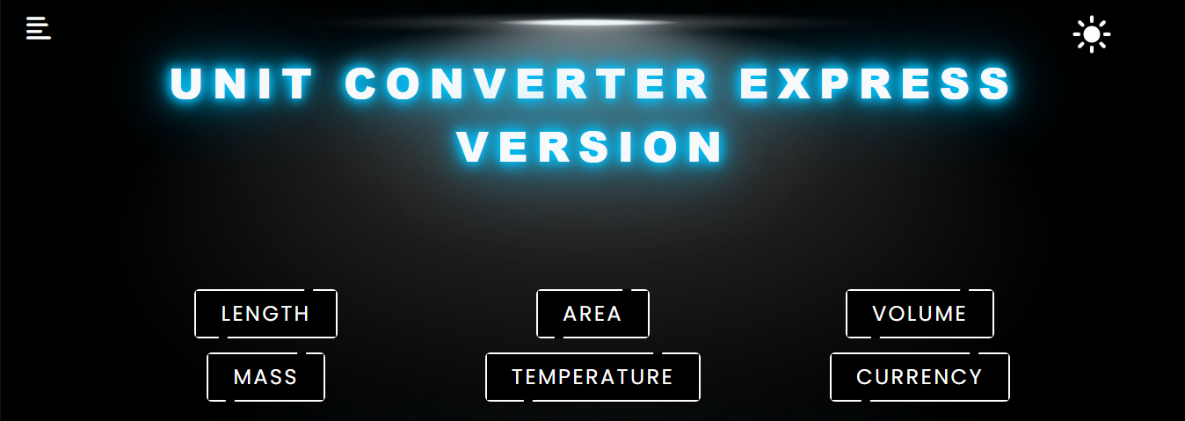

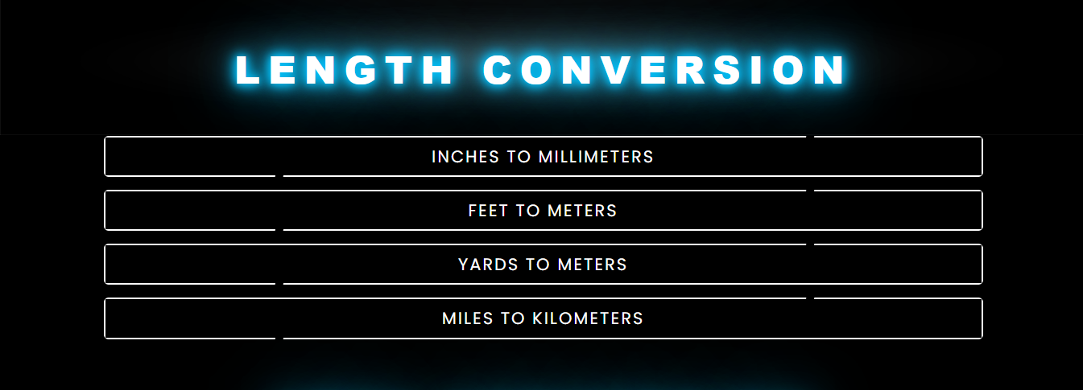

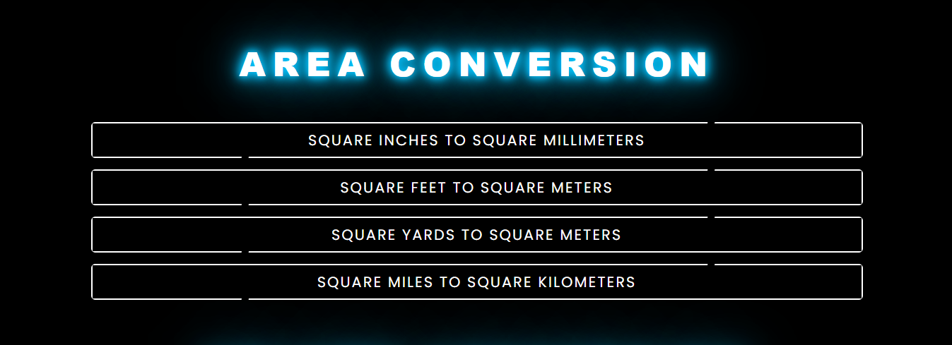

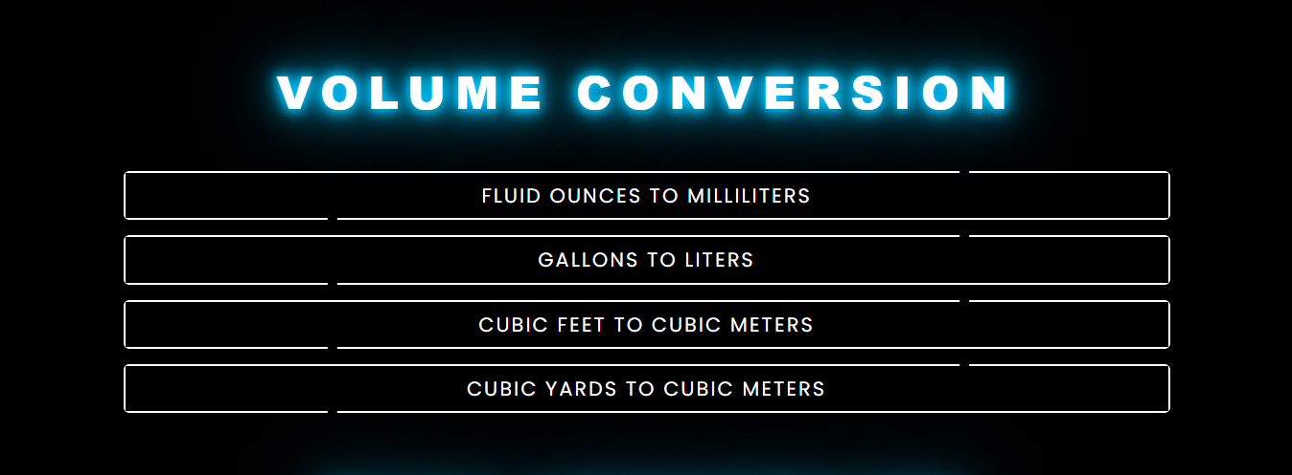



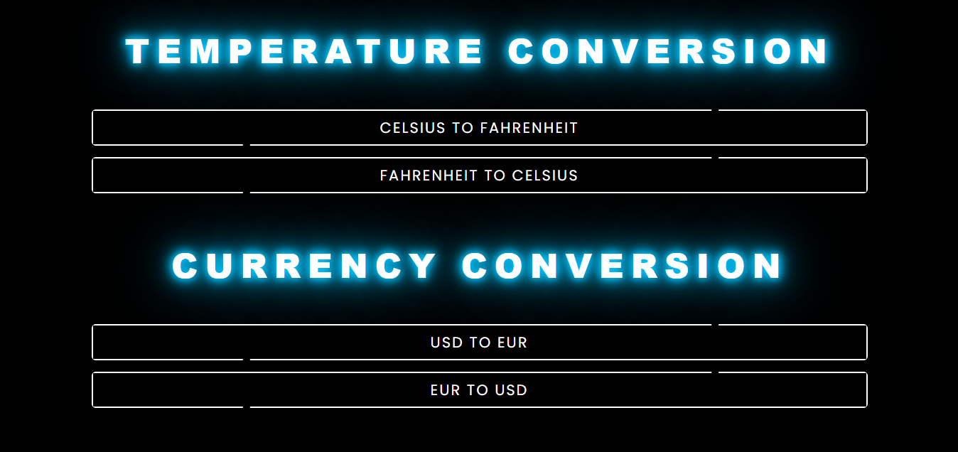

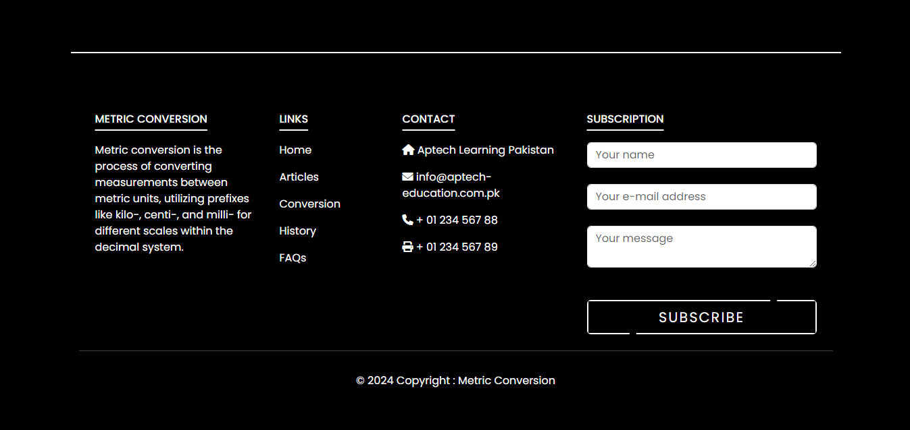

* This is the Home Page of Bright World containing nav bar with main dropdown containing 3 top brands with each brand having 3 sub-categories.

**How to use home page:**

Basically, home page is divided into:

1. Advertisement section
2. Top Brands Accordion
3. Color changing header linked to Gallery
4. Hot Sale items
5. New Arrivals for sale analysis
6. Testimonials

## Nav Bar

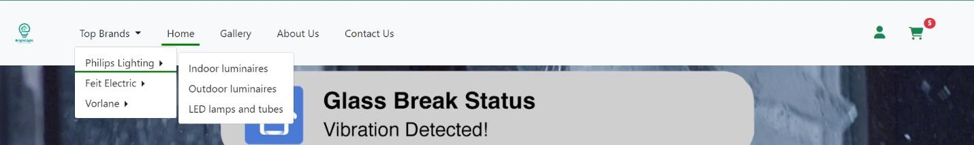

Nav bar contains links of: -

1. Top Brands
2. Home
3. Gallery
4. About Us
5. Contact Us

In Top Brands there are 3 types of brands each having 3 sub categories

On the left side we have a profile icon which on dropdown shows a log in button which navigates to login page if user did not log in and if logged in shoes the User name of User and log out button

After that there is a Shopping Cart which is operated by Api showing items and their quantity inside the cart with total amount of all items combined, Total items are showed on the badge above the cart icon

## Footer

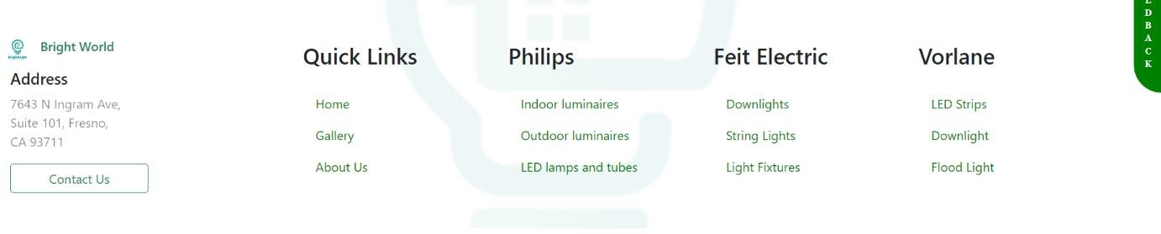

Footer contains links of: -

* 1. Home
  2. Gallery
  3. About Us
  4. Contact Us
  5. Phillips Categories
  6. Feit Categories
  7. Vorlane Categories

Hover Effect is added with box-shadows to insure Attractivity

Background image is added to improve visibility and uniqueness

## Screenshots of Home Page

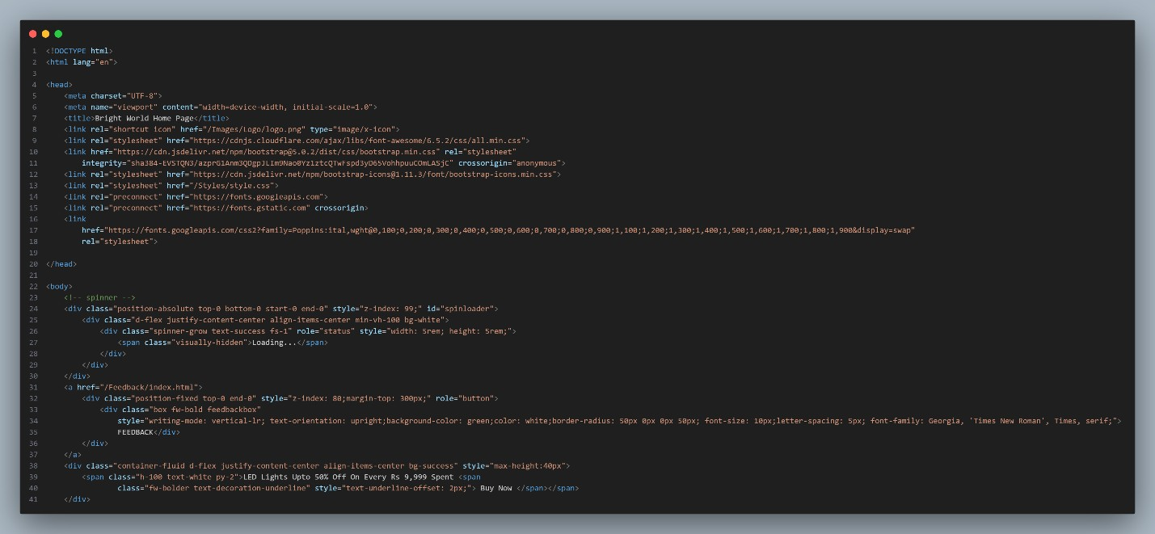

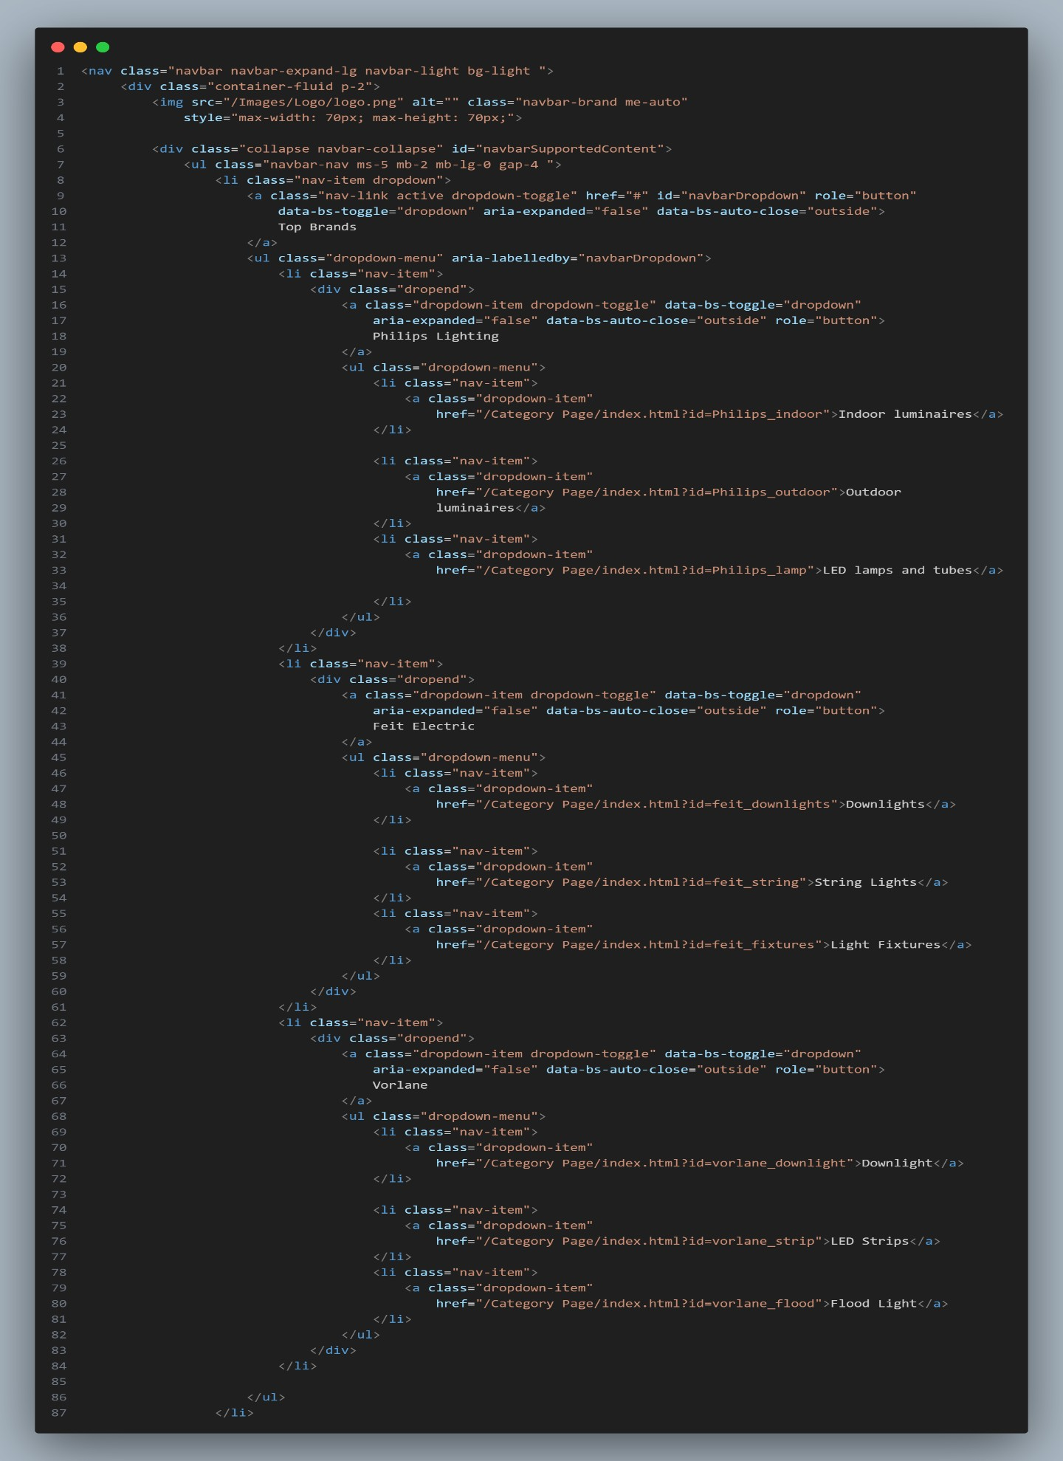

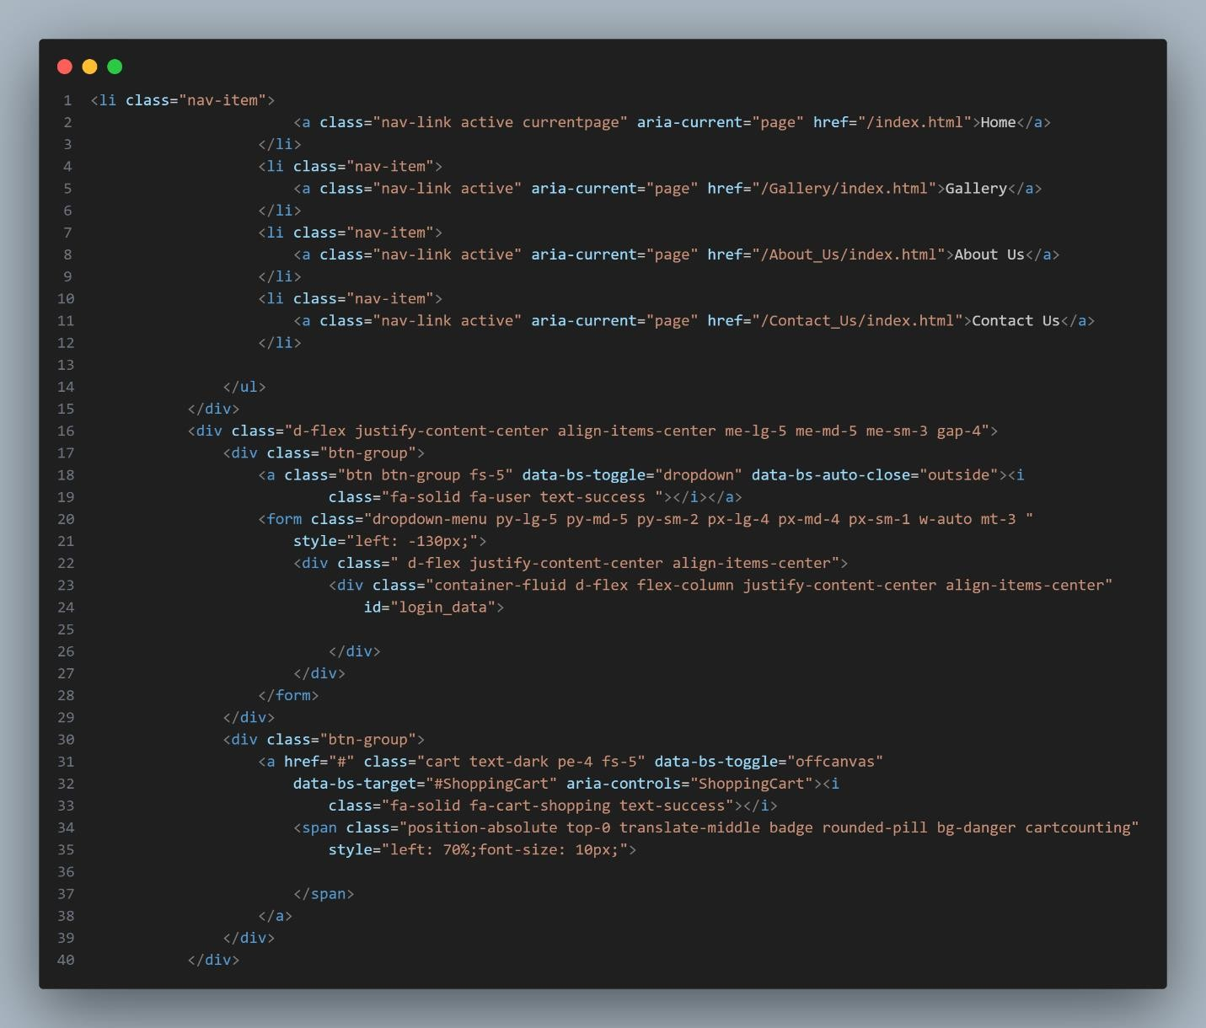

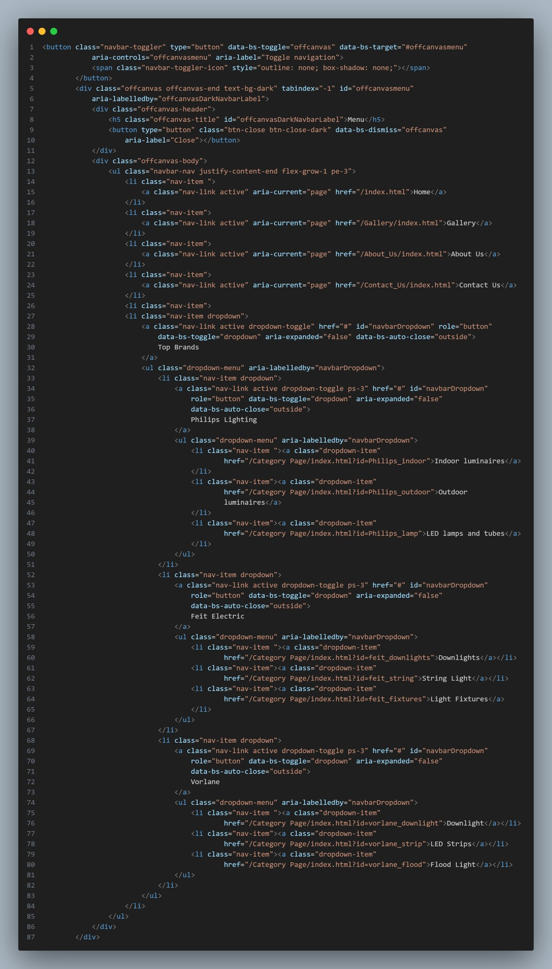

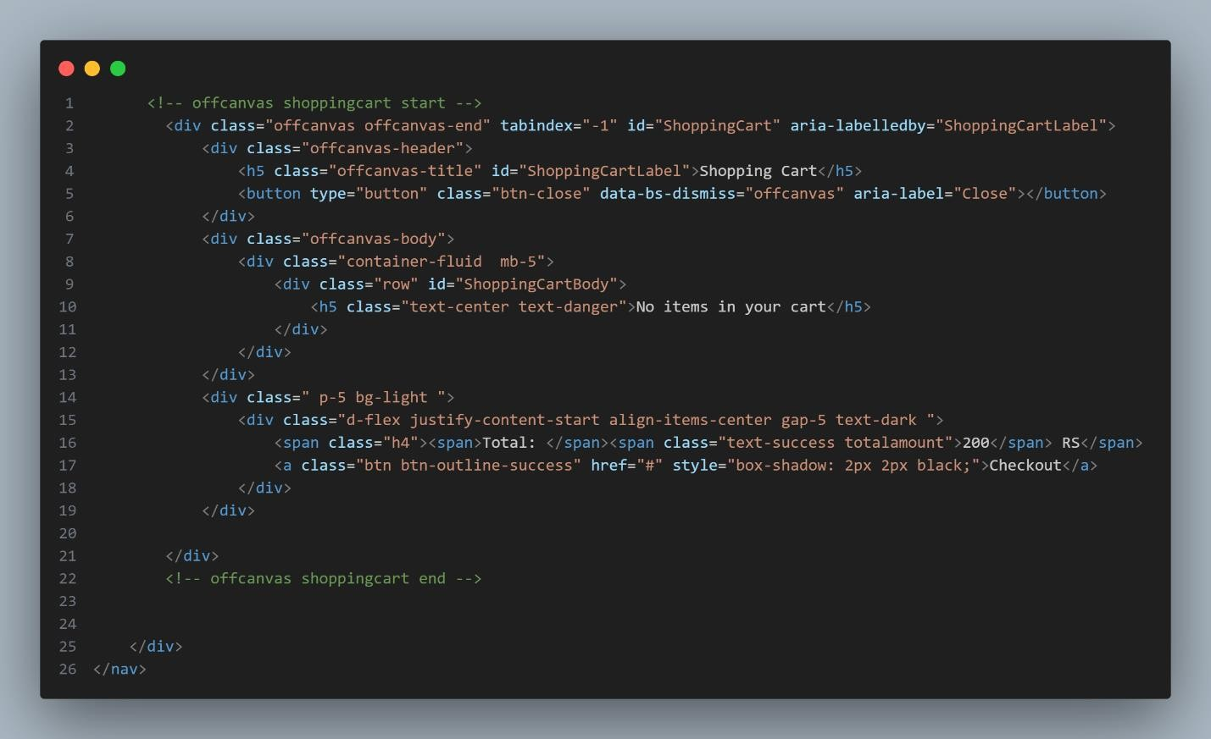

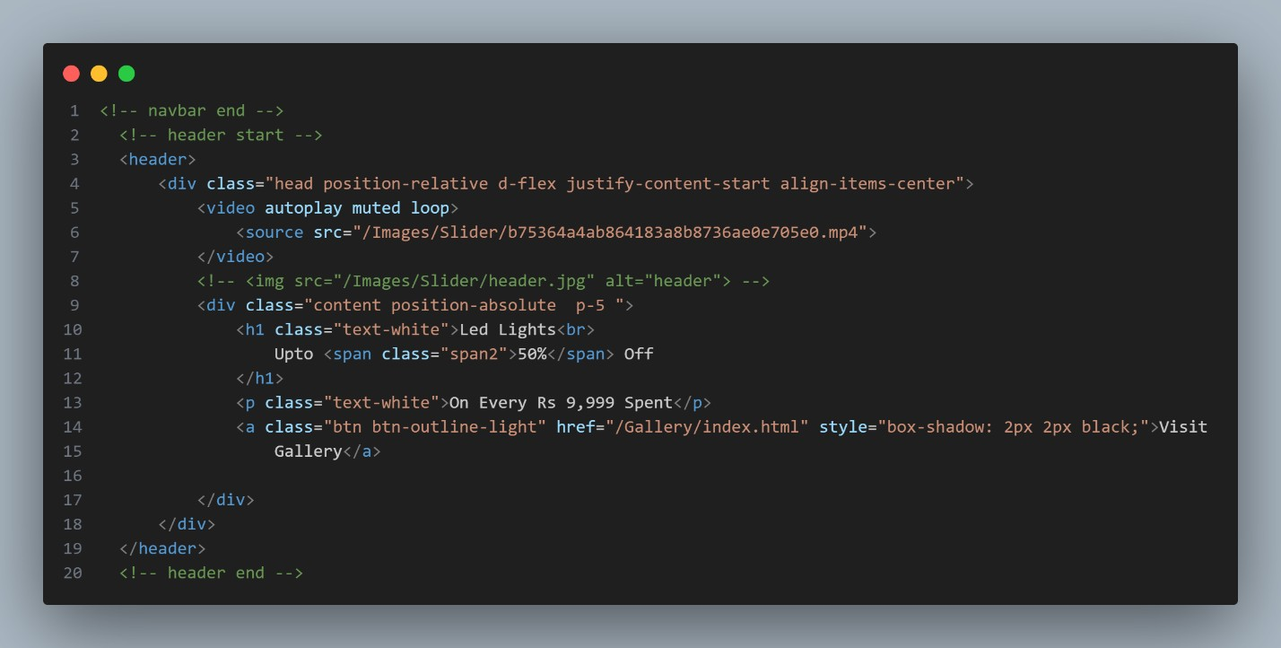

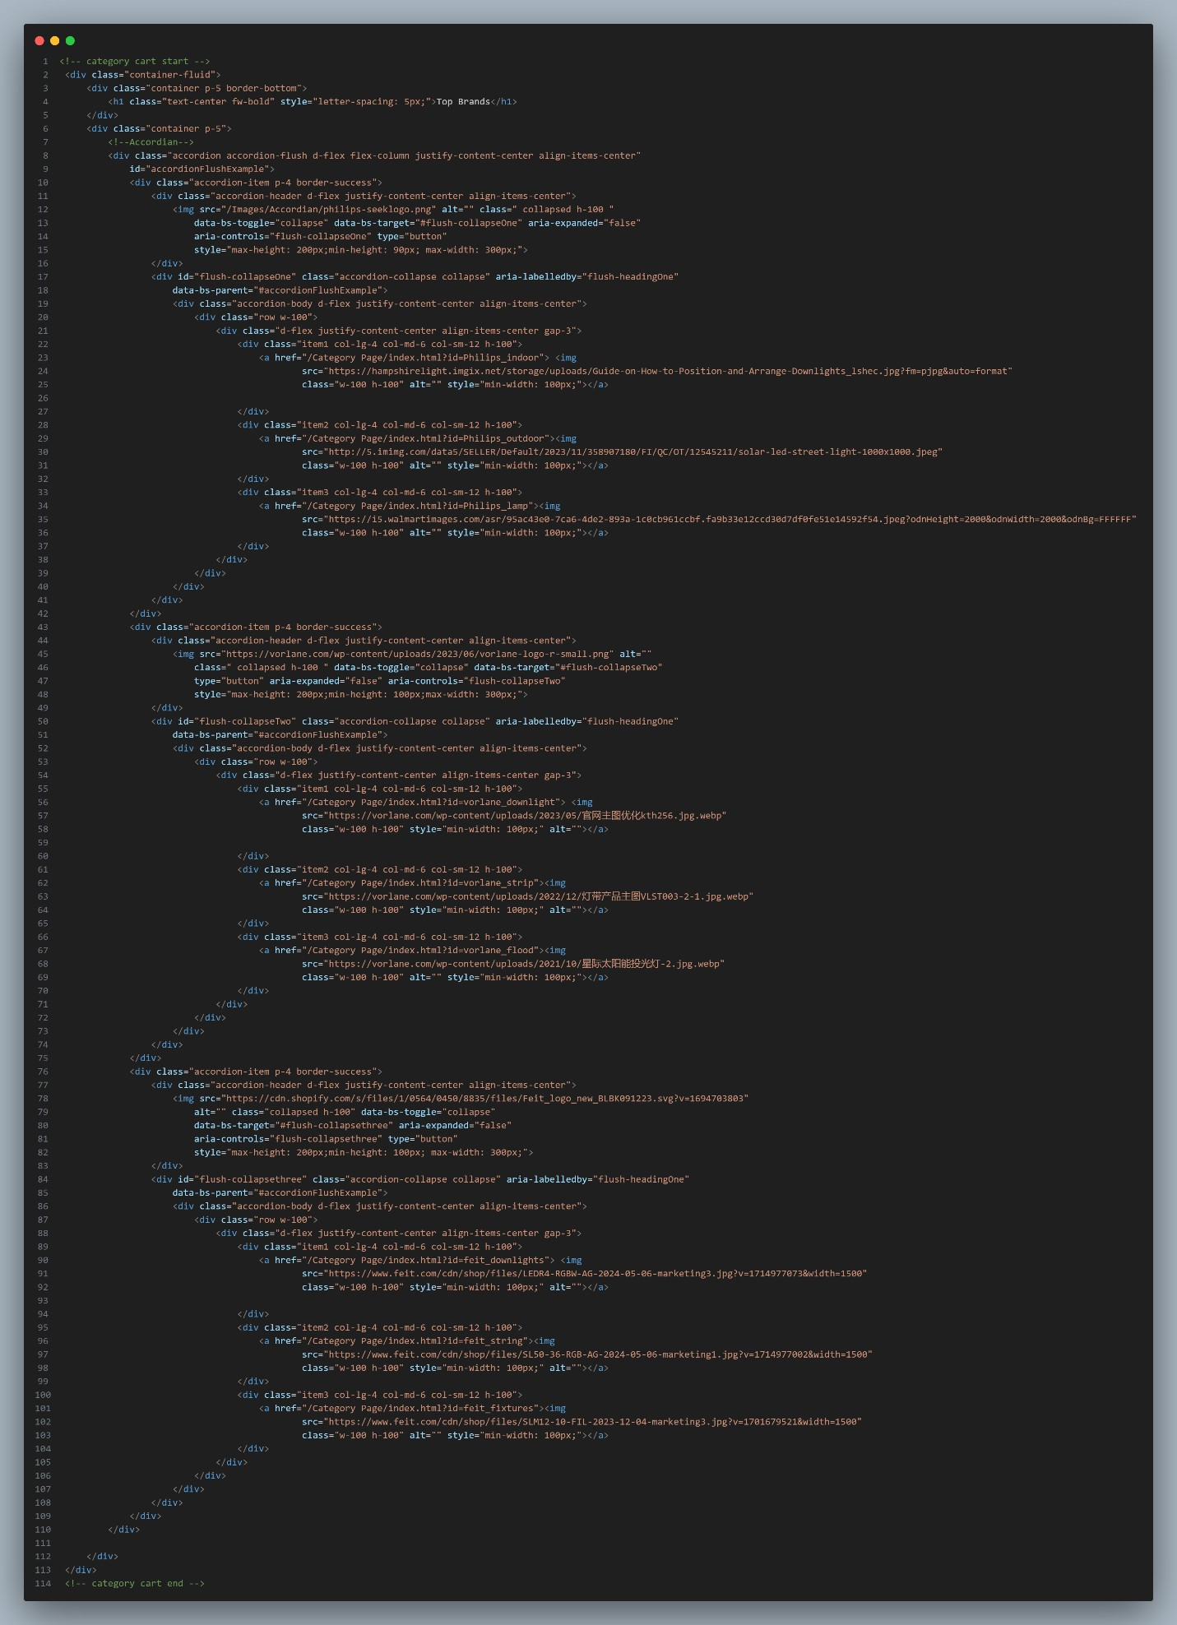

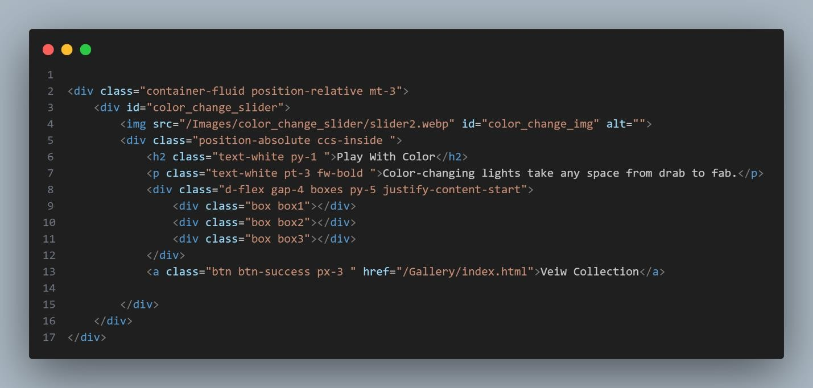

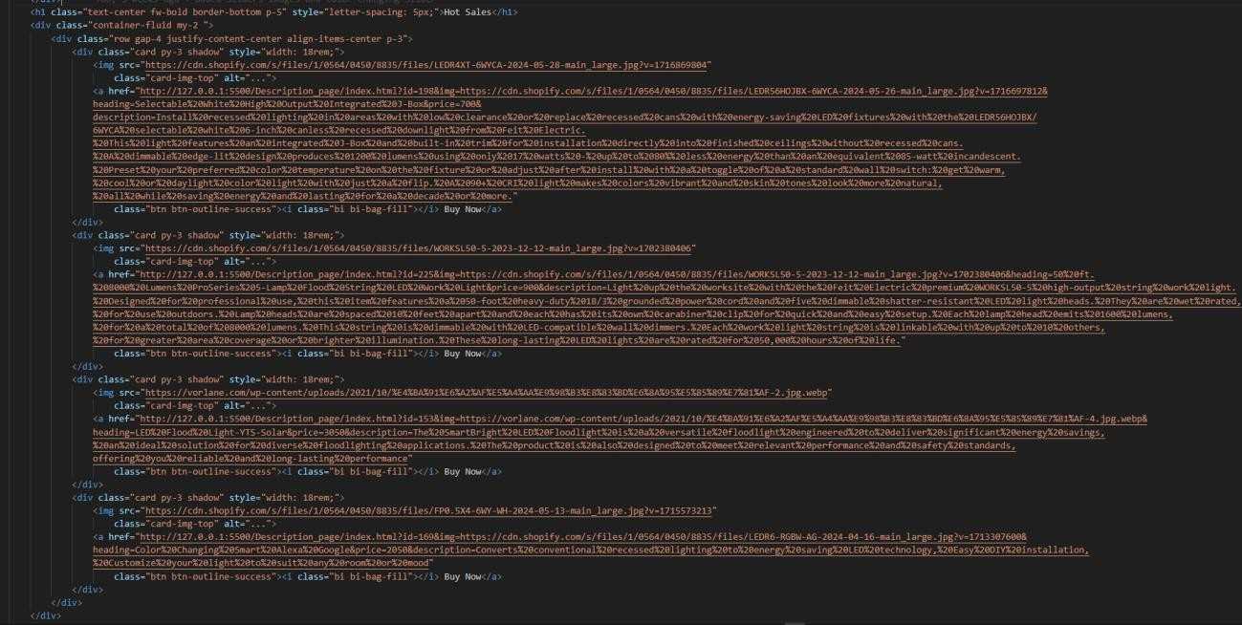

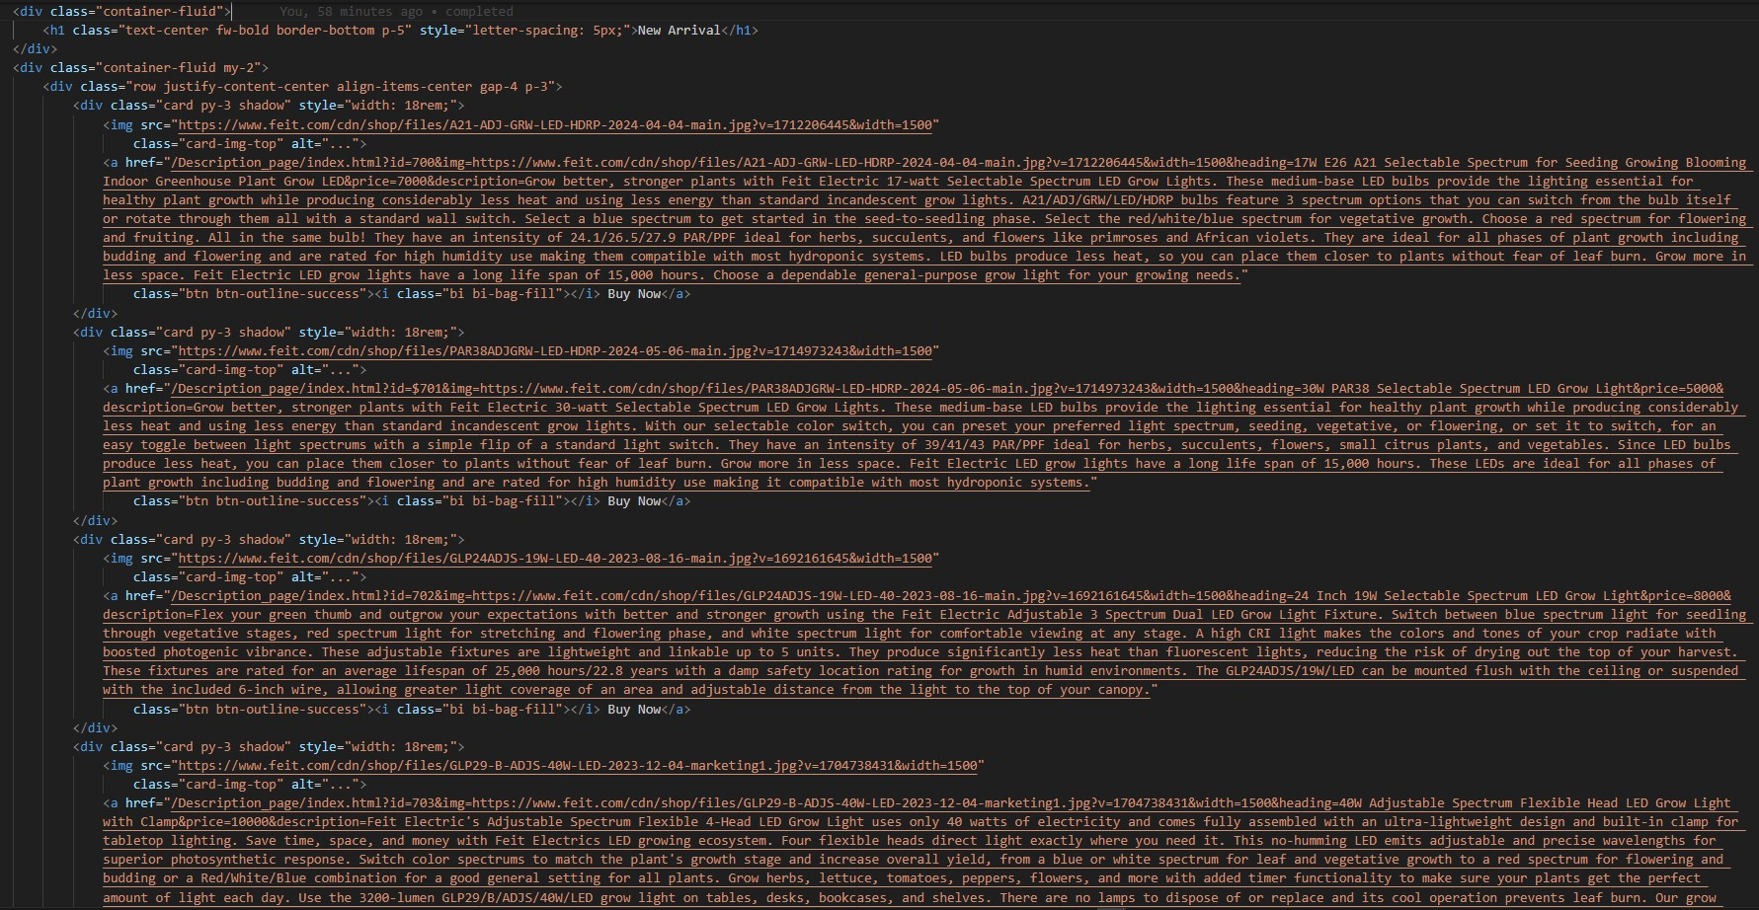

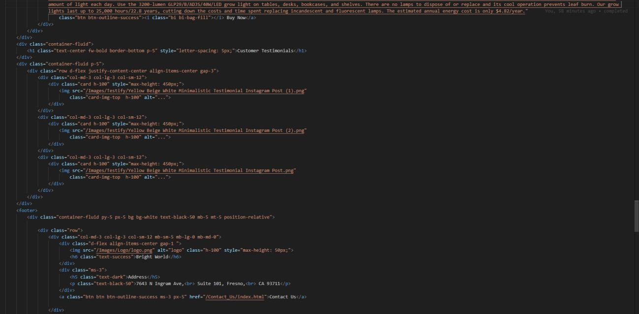

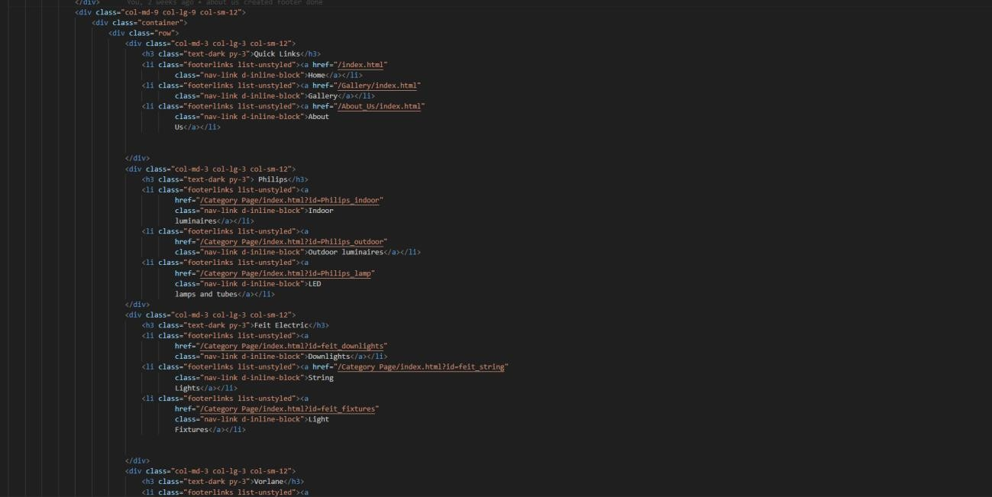

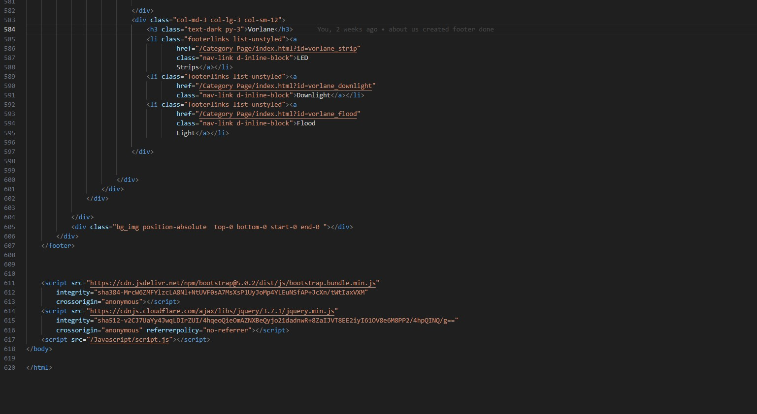

***CSS: -***

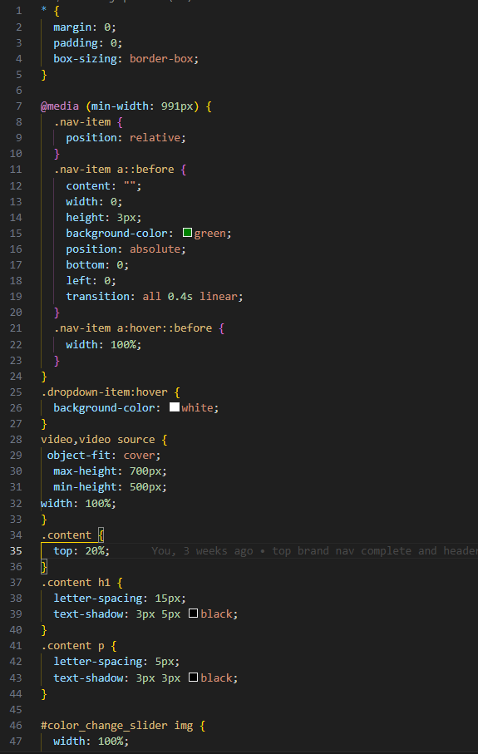

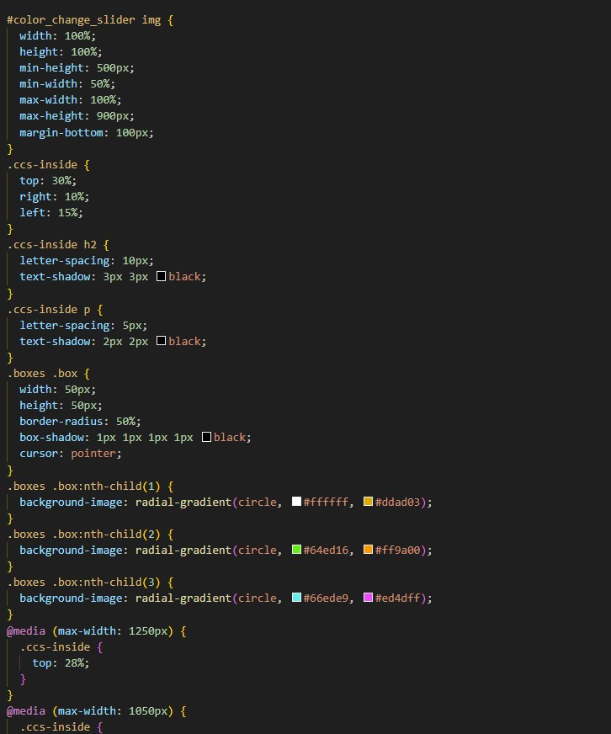

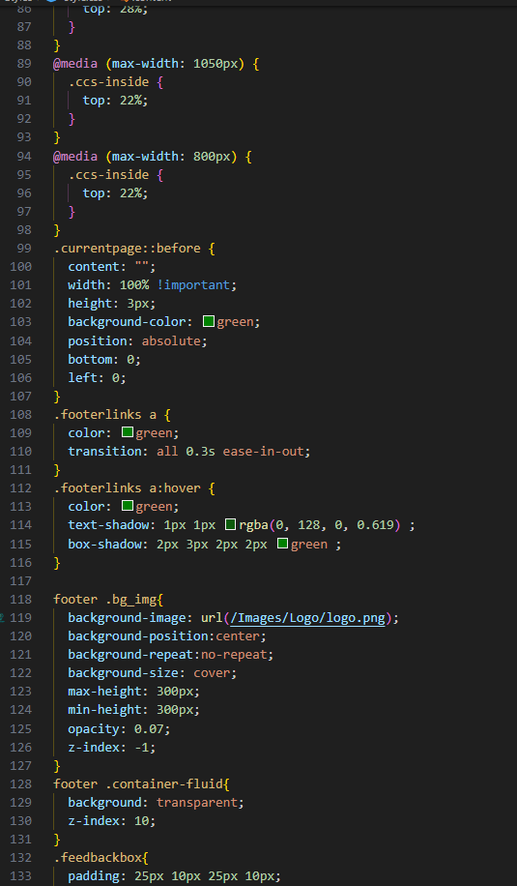

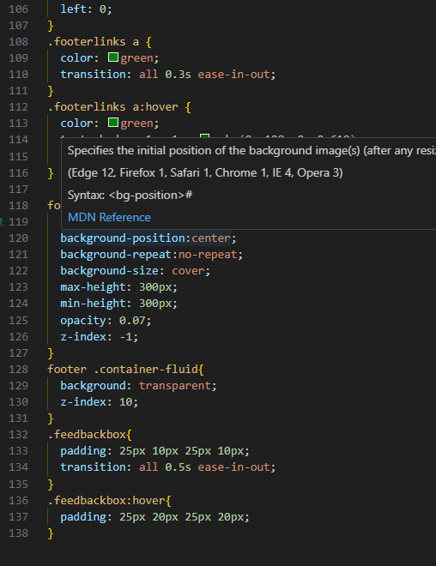

***JAVASCRIPT: -***

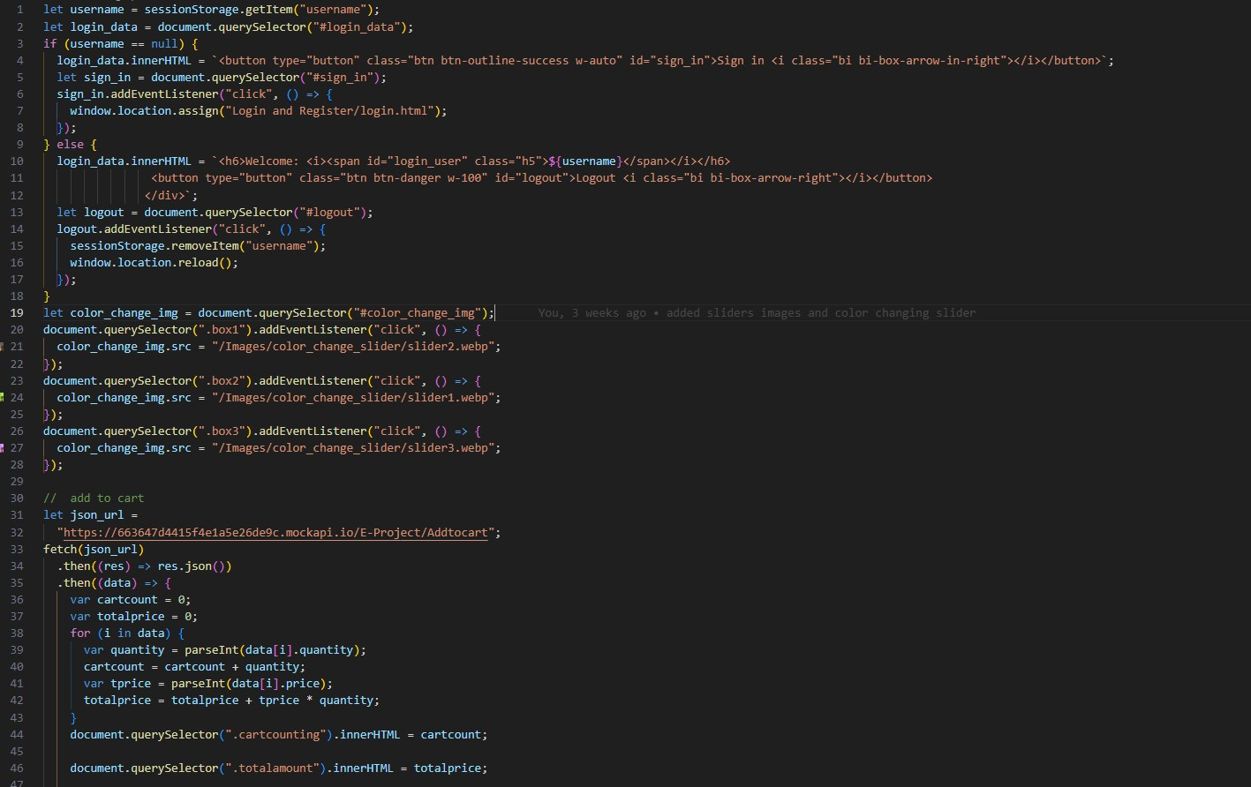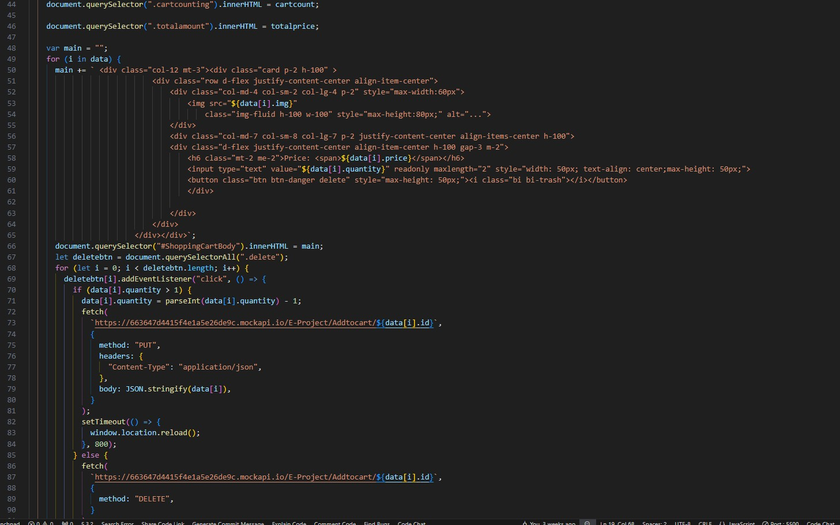

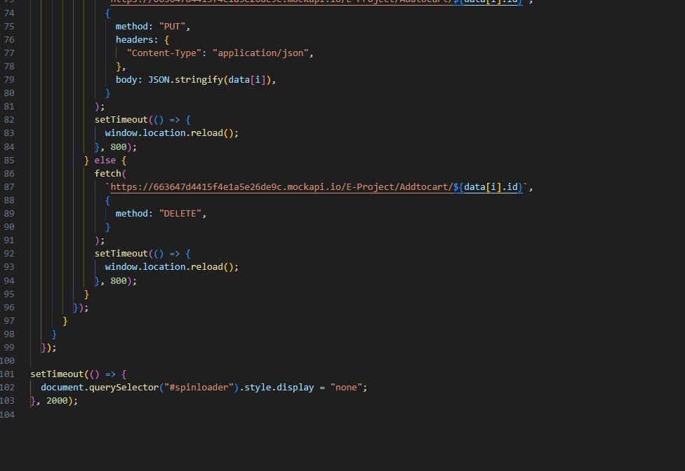

**Github Link:-** https://github.com/MArsalanwarsi/E-Project-Bright-World.git

